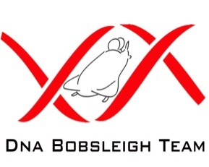
Reference: DNA Bobsleigh Team 16 Agnew Road
Dated: 9th April 2013 Bridgemary
Gosport
Hampshire
PO13 0JD
Dear Sir / Madam
The DNA Bobsleigh Team was put together in early 2010 when an opportunity arose to compete against an RAF bobsleigh team in a charity event. The team spent many months training with the RAF and other GB Squads, and it all came together at Igls, in Austria, late 2011. Our squad performed very well at this event, and we realised that we had the talent, aptitude and desire to compete on the European Circuit. This has spurred us on to formalise the team structure, to train more regularly and to take the necessary steps to enable us to compete at European level from the end of 2013 onwards.
DNA Bobsleigh is looking for sponsorship to help defray some of the equipment, transportation and accommodation costs involved. I have been appointed the team’s Sponsorship Manager and I am therefore writing to ask if you would be kind enough to help fund the DNA Bobsleigh Team.
We will be competing at tracks in Germany, Switzerland, Austria, Italy, Norway and France over a five month period, in local competition and cup races. We will also be entering the 2014 British Championships (location to be confirmed). We will endeavour to keep our costs down to a minimum by temporarily storing the equipment at a track, or military base, in Germany and retrieving it from there when required for the next race.
Your funding, however small or large, as per the ‘Sponsorship Packages’ attached, would assist us greatly in achieving our goals and objectives. There are numerous sponsorship packages available, in return for company branding. If you become the ‘Title Sponsor’ there is a possibility for one or more of your employees to be taken down in a four man “Taxi Bob” and/or to join the DNA Bobsleigh Team itself?!
We would be so grateful for any financial assistance you can provide.
If you would like to get involved or require further information, please contact me by e-mail or telephone.
Thank you very much indeed. John Bird
Sponsorship Manager for DNA Bobsleigh Team
E-mail: bobsleigh@hotmail.co.uk
Tel: 07875 700505
www.dnabobsleighteam.webnode.com

