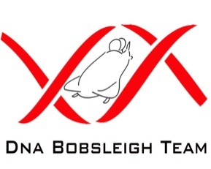
DNA Bobsleigh Team
Sponsorship Packages
Title Sponsorship/Gold (£20,001 – Unlimited)
- On the Bobsled
- On the lorry/van (UK & European travel, once we purchase one)
- On the website
- On all our clothing (training & race - UK & abroad)
- UK and/or worldwide Media (to be discussed)
- On our main race suits
- On the helmets
- On our travel bags
- Facebook & Twitter pages
- One or more of your employees will get the chance to go in a ‘Taxi Bob’
* You can also use us for Company Promotion & Marketing purposes (Gold package only)*
** There are opportunities to advertise at each track, but at a cost to you, this is controlled by the Track Managers **
Associate Sponsorship/Silver (£10001 – £20,000):
- On the Bobsled
- On the lorry/van (UK & European travel, once we purchase one)
- On the website
- On our training suits
- Facebook & Twitter pages
Supporting Sponsorship/Bronze (£3000 - £10000):
- On the website
- On the lorry/van (UK & European travel)
- Facebook & Twitter pages

