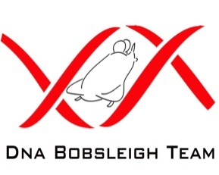

DNA Bobsleigh Team
Recruitment Information

DNA Bobsleigh is searching for fifteen new sliders to become part of the squad.
Please read the enclosed ‘Selection Criteria’ form.
As we will be working alongside the Great British Bobsleigh Association and inline with the FIBT rules & regulations, it is imperative you attend all, or as many, training sessions as possible.
As part of the application process, an assessment day* will be scheduled for successful applicants to be assessed by the team’ selectors.
If you think you have what it takes to join the DNA Bobsleigh Team, please fill out the application form and return it to: bobsleigh@dnasport.com by Friday 30th August 2013.
You will then be invited to attend a *fitness evaluation test & informal interview shortly after. Applicants may be asked to complete further fitness/athletic tests (if required).
Full details of the team can be found at: www.dnabobsleighteam.webnode.com

John Bird
Team Director
Tel: 07875 700505
E-mail: bobsleigh@dnasport.com
Bobsleigh experience is not essential or required, as we will train you.
Subs may be payable for all team members.

