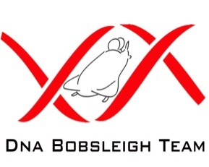
DNA Bobsleigh Team
Selection Criteria

- Over 18 years of age.
- Male or Female.
- Have some level of fitness, although not essential for the application stage.
- Must not be over 110kgs in weight*.
- Must be 100% committed, have the desire to train and be part of a team.
- Must be able to attend at least 80% of meetings and Bath Push Start Track Sessions.
- Must be able to get time off work when required**
- Must be willing to sign all relevant documentation, i.e disclaimer, medical & contract forms, etc. These will be sent to you if you pass the fitness and interview assessment day.

* There is an all up weight for a ‘two man’ bobsled of 390kgs. The sled itself is 200kgs, so between the crew members we need to divide up the 190kg weight. The rear of the sled requires weight too, as it will waver on the track if to light, so we can’t allow anyone to race under 80kgs. The ideal would be to have even weight, but the faster of the two people on the back.
** You will be part of a 15-20 person squad and will be selected to race depending on your commitment, desire, achievements in training, attitude and aptitude, etc. It is not automatic selection.

